WEEKLY REVIEW AND PRACTICE PRATICAL

Q1. On Cisco Packet Tracer, create a network with three switches and assign at least two different VLANs (e.g., VLAN 10 for 'Sales', VLAN 20 for 'Support'). Connect two PCs to each switch and assign each PC to the correct VLAN based on department.
Ans. I have created two VLAN on all 3 switches and assigned each pc to VLAN correctly.
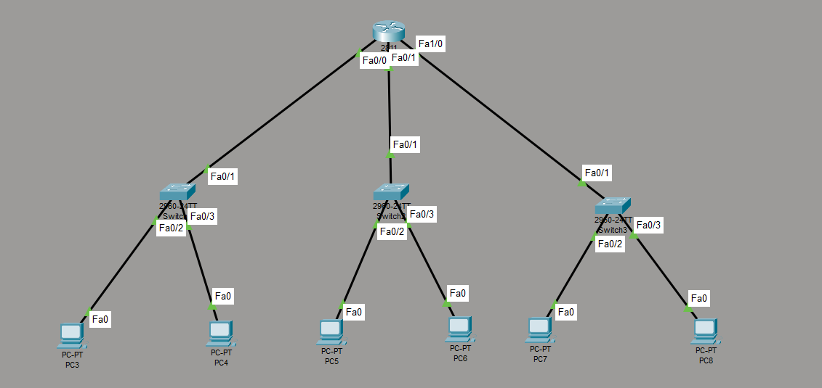
Q2. Configure trunk ports between the switches to allow VLAN traffic to pass through. Verify trunking by using the show interfaces trunk command and submit a screenshot of the output.
Ans. I have configured trunk ports between switches to allow all VLAN traffic to pass through and also verified it using the show interface trunk command.
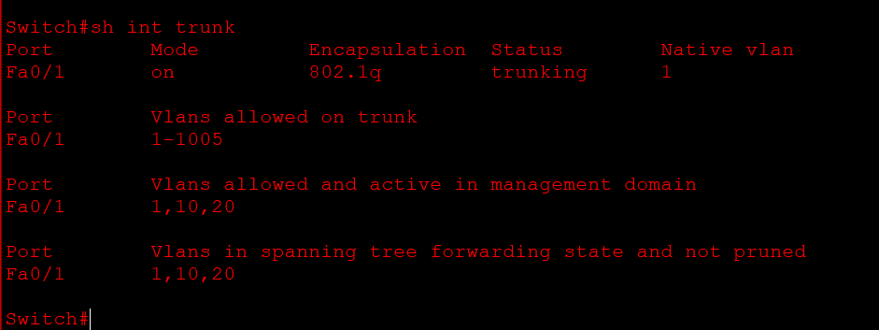
Q3. Set up a Layer 3 device (Router-on-a-Stick using a router or a multilayer switch) to enable inter-VLAN routing between VLAN 10 and VLAN 20. Assign appropriate sub-interfaces and IP addresses for each VLAN.
Ans. I have setup a layer 3 device (Router-on-a-Stick using a router) to enable inter-VLAN routing between VLAN 10 and VLAN 20 and assigned a appropriate sub-interfaces and IP addresses for each VLAN.
Q4. Test connectivity by pinging between a PC in VLAN 10 and a PC in VLAN 20. If pings fail, troubleshoot and fix the configuration so that inter-VLAN communication works. Hint: Check sub-interface IPs, trunk configuration, and default gateways on PCs.
Ans. I have checked the connectivity by pinging a VLAN 10 pc to a VLAN 20 pc and it doesn’t gets failed It work perfectly and communicating with the pc on other VLAN.
